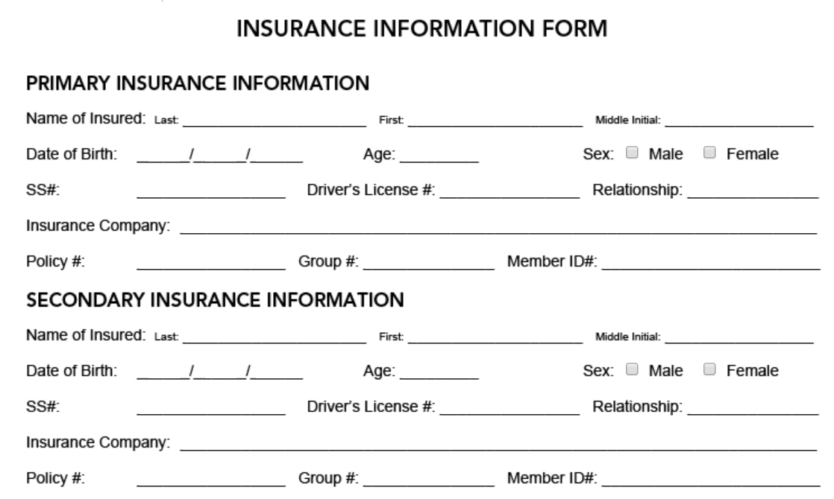



AUTHORIZATION

I hereby authorize Jeff Vanzant and *Bright Hearts Counseling* to look into my insurance coverage and benefits with the information I have provided above for billing purposes.

I hereby authorize Jeff Vanzant MA to provide psychological care and treatment and to release my personal information to my insurance company as necessary for the payment of benefits. I also hereby authorize my insurance company to pay benefits directly to Jeff Vanzant, MA. These authorizations remain valid and effective from the date of signing until revoked in writing.

FINANCIAL RESPONSIBILITY

I understand that I am financially responsible for the cost of all psychotherapy services rendered *by JEFF VANZANT, MA. JEFF VANZANT, M.A.* will bill my insurance company strictly as a courtesy to me but any portion of my psychotherapy bill that does not get paid by insurance, including but not limited to co-payments, deductibles, and non-covered amounts will be my responsibility. I understand that any invoices sent by JEFF VANZANT M.A. or anyone associated with his business (*Bright Hearts Counseling*) are due upon receipt and that failure to keep my account up to date and current may result in my being denied additional services. I acknowledge and have read and understand my responsibilities.

Full name: _________________________ Date: ___________________________________

Signature: _________________________________

Full name: _________________________ Date: ___________________________________

Signature: _________________________________